Practice Problems : Chapter 3
- A function is given by $f(x)=x e^{-3x}+x^{2}$. Now answer the following up to five significant figures.
  - Approximate the derivative of $f(x)$ at $x_{0}=2$ with step size $h=0.1$ using the central difference method.
  - Calculate the upper bound of the truncation error of $f(x)$ at $x_{0}=2$ using $h=0.1$ using the central difference method.
  - Compute ${D^{(1)}}_{0.1}$ at $x_{0}=2$ using Richardson extrapolation method and calculate the relative error.
- During the derivation process, we explored the first-order Richardson extrapolated derivative using 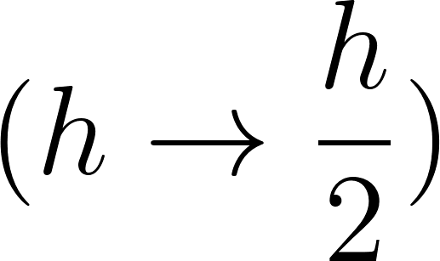,
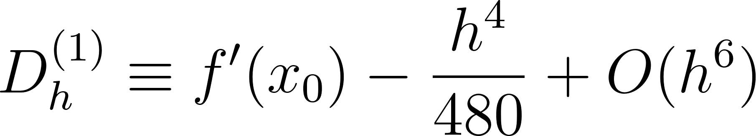
- Using 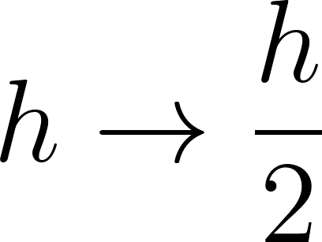, derive the expression for 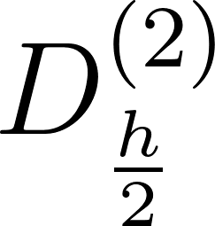, which represents the second-order Richardson extrapolation.
- Now, starting from the definition of 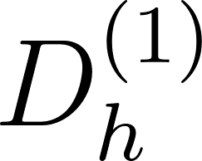 and applying 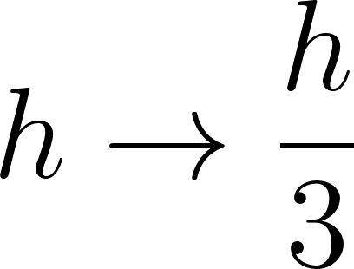, derive the expression for .

- Consider the function 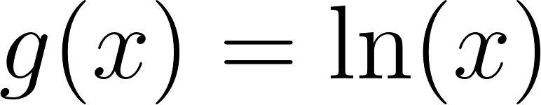,
  - Approximate the derivative of 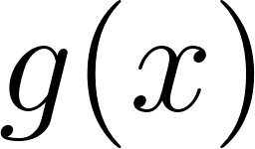 at 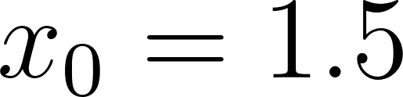 with step size  using the central difference method up to 6 significant figures.
  - Approximate the derivative of at with step size using the forward difference method up to 6 significant figures.
  - Calculate the truncation error of 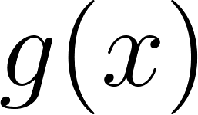 at using 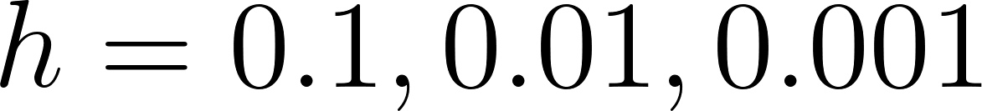 in both the central difference and forward difference methods.
  - Compute Compute 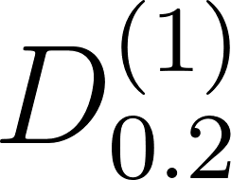 at using Richardson extrapolation method up to 6 significant figures and calculate the truncation error. at using Richardson extrapolation method up to 6 significant figures and calculate the truncation error.
- Given the function 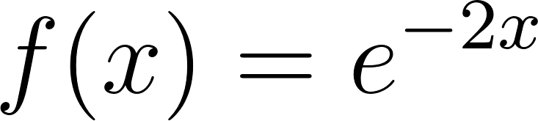:
- Approximate the derivative of 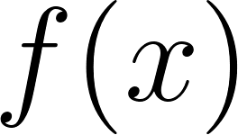 at 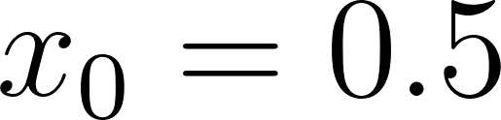 with step size using the forward difference method up to 6 significant figures.
- Approximate the derivative of at with step size using the central difference method up to 6 significant figures.
- Calculate the truncation error of the derivative approximation at using for both the forward and central difference methods.
- Compute at using Richardson extrapolation up to 6 significant figures and calculate the truncation/relative error.

- Consider the following data table::

x | 1.1 | 1.2 | 1.3
f(x) | -0.57941 | -0.90730 | -1.2807
  - Using the above data, compute f'(1.2) using the central difference method.
  - For the interval [1.1, 1.3], compute the error bound (truncation error) if the above data is generated by the function, $f(x) = x cos(x) - x^{2}sin(x)$.
  - Also compute the actual error.

